Capture the Flag (CTF)
Challenge on Disinformation • Instructor • Challenge 1

Index

Objective 4
Problem 4
Article 1 5
Article 2 6
Article 3 8
Article 4 11

Objective
Identify which of these articles describe genuine events, and which ones are completely fabricated.

Problem
As social media becomes people’s main news source, fact checking is more important than ever. Below, we have included some examples of archived news articles that have trended on Facebook or Twitter in the past few years.

Article 1

Description:
The participant needs to identify whether the article below is Real or Fake.

Link:
https://web.archive.org/web/20161028110201/https://www.politico.com/states/florida/story/2016/10/bowden-stumps-for-trump-in-tampa-106687

Screenshot:
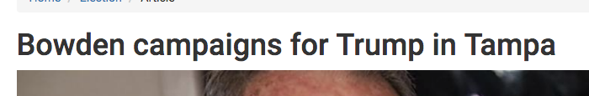
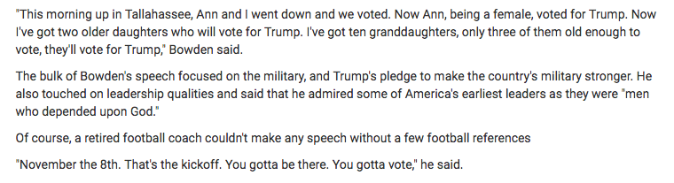

Expected Answer
Real

Article 2

Description:
The participant needs to identify whether the article below is Real or Fake.

Link:
https://web.archive.org/web/20190130014540/https://www.nbcnews.com/pop-culture/pop-culture-news/patton-oswalt-helps-man-who-trolled-him-twitter-raise-30-n962706

Screenshot:
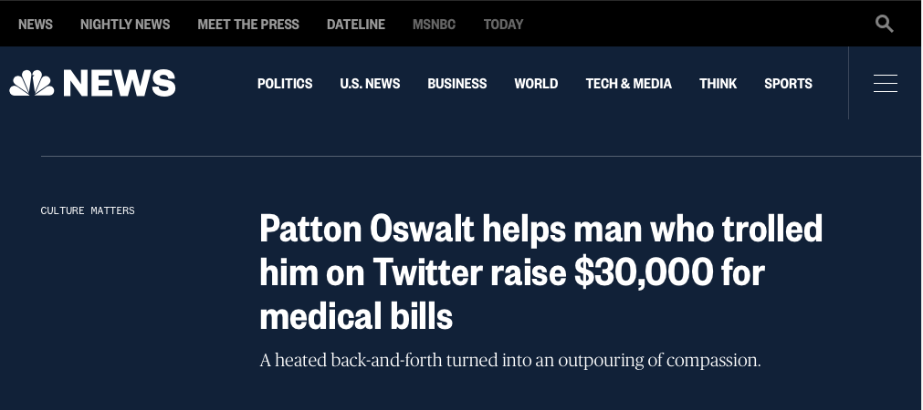
(Image 1 – Article headline)

Article:
By Elisha Fieldstadt
Comedian Patton Oswalt responded to a Twitter troll's mean message with kindness, helping the man raise more than $30,000 for medical bills.
Twitter user Michael Beaty responded to a not-safe-for-work anti-Trump poem Oswalt had posted to Twitter Wednesday with two angry tweets.
"I just realized why I was so happy you died in Blade Trinity!" Beaty responded to Oswalt. "And you shoot basketball ike (sic) the sawed off little man you are," he added in a second tweet.
Oswalt, who is often outspoken on Twitter, said he had responded to Beaty in kind, "but then I looked at his timeline and he’s in a LOT of trouble health-wise. I’d be pissed off too. He’s been dealt some sh**ty cards — let’s deal him some good ones."
"Click and donate — just like I’m about to," Patton wrote in the tweet that included a post from Beaty seeking "Help after Sepsis, Diabetic Ketoacidosis and Coma," with a link to a GoFundMe account. The description on the page said Beaty was in the hospital for two weeks and was looking at "massive medical costs" and a long recovery.
By Friday morning, donations to Beaty's GoFundMe had surpassed the $5,000 goal by more than $26,000.
"I want to thank everyone who came to my aid with generous outpourings- and also to @pattonoswalt without whom I would not be the recipient of so much love and support. I'm not a man who ever cries but I had to wait to send this," Beaty wrote on Twitter in response.
In addition to feeling grateful, Beaty also had a change of heart.
Oswalt "managed to not only let me slide on a rough tweet to him but started something that has me reevaluating friendships and productive dialogue regardless of political affiliation," Beaty wrote in one tweet.
"Patton. You have humbled me to the point where I can barely compose my words. You have caused me to take pause and reflect on how harmful words from my mouth could result in such an outpouring," Beaty added.
Patton, not known to pass up an opportunity to make people laugh, tweeted Thursday: "See, THIS is why compassion and forgiveness are the best — wait, you CRIED?!? You f*****’ p****! Donation CANCELLED."
Patton also promised an upcoming performance in Alabama, where Beaty lives.

Analysis
This article covers a conversation on Twitter between comedian Patton Oswalt and a man named Michael Beatty. While the article does not provide links to any of the tweets directly, searching the quotes on google verifies the accuracy of the quotes. The GoFundMe mentioned in the article also exists on gofundme.com.

Expected Answer:
Real

Article 3

Description:
The participant needs to identify whether the article below is Real or Fake.

Link:
https://web.archive.org/web/20161115024211/http://wtoe5news.com/us-election/pope-francis-shocks-world-endorses-donald-trump-for-president-releases-statement

Screenshot:
(Image 1 – Article headline)

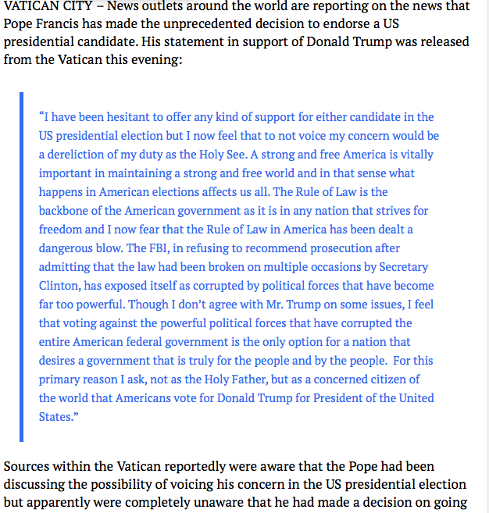
(Image 2 – Article body)

Analysis
This article is designed to look like a press release issued by the office of Pope Francis, and the site itself is designed to look like a local news site. If genuine, the quoted block of text would appear in multiple news sources and be heavily discussed in the news. A google search of any part of the quote almost exclusively links back to this site.

Expected Answer:
Fake

Article 4

Link: https://web.archive.org/web/20161115023815/http://denverguardian.com/2016/11/05/fbi-agent-suspected-hillary-email-leaks-found-dead-apparent-murder-suicide/

Screenshot:
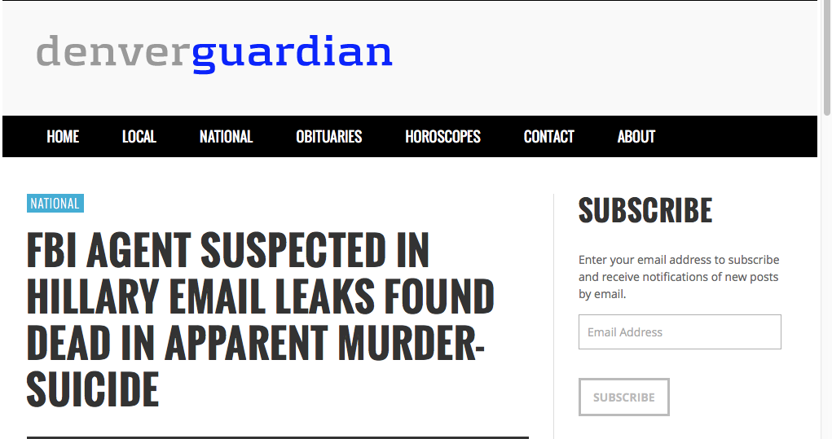
(Image 1 – Article headline)

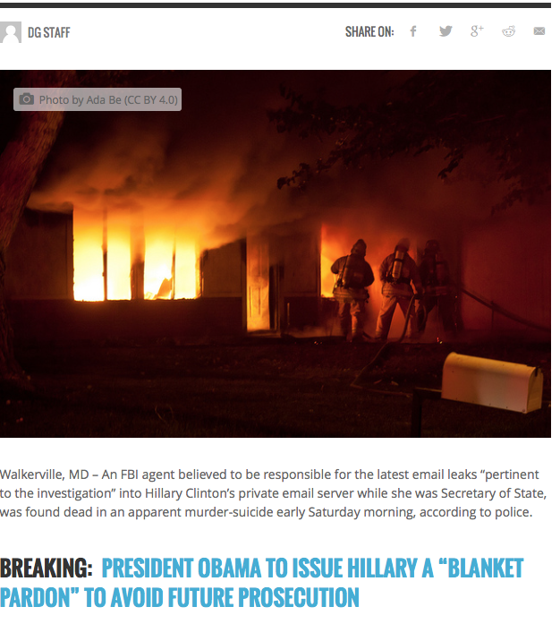
(Image 2 – Article header)

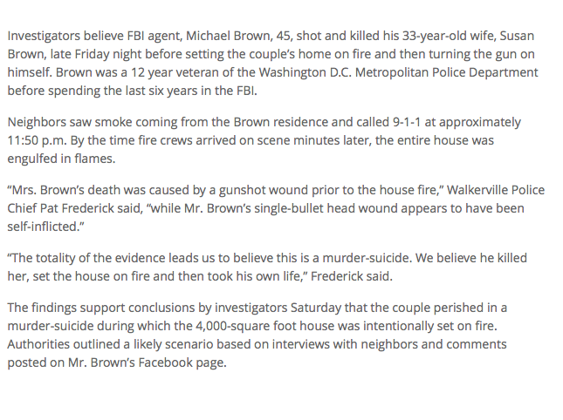
(Image 3 – Article body)

Expected Answer:
Fake

