Capture the Flag (CTF)
Challenge on IoT Forensics • Instructor • Challenge 1

Index

Assumptions/Needs 4
Objective 4
Problem 4
Task 1 4
Task 2 6
Task 3 7
Task 4 8

Objective
The user’s objective will be to use a filesystem debugger tool to read a baseline timestamp on a few files. After establishing the baseline timestamps, a malicious actor will make modifications to some of the files. The user will have to determine which files were affected, when the attack took place, and what was done.

Problem
You suspect that you have experienced a breach. Your job is to determine the extent of the breach and when the breach occurred.

Assumptions/Needs
- Hyper-V software for virtual Rasperry Pi
- Raspbian Stretch OS
- debugfs enabled in Linux.

Task 1

Description
The first task is to create 3 files and collect baseline timestamps. You can assume that these timestamps were taken before the breach. Identify the inode of each file and upload screenshots of both the inode number and the metadata viewer.

Expected Answer
The timestamps should include the debugfs stat readout containing c-time, cr-time, m-time, and a-time. Separate timestamp readouts should be included for each file. Additionally, the user should run ls -i to display the inode numbers of each file.

Screenshots should look like this:
Initial run of ls -i to see the inode numbers on all files.

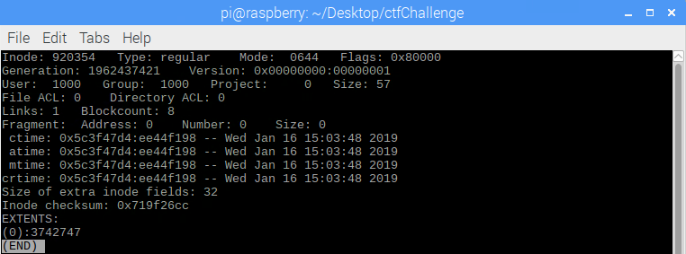
Base line run of file1.txt

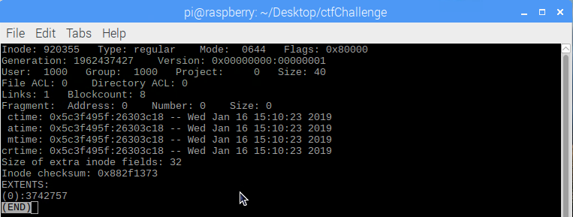
Baseline timestamp of file3.txt

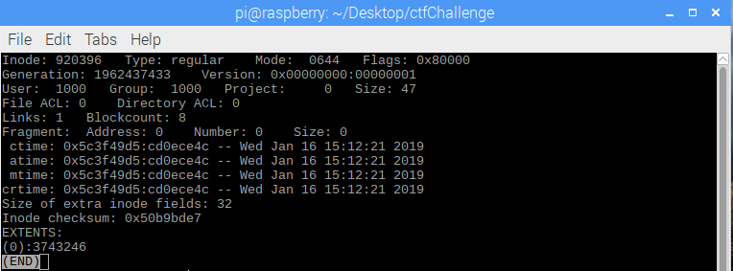
Baseline timestamps for file4.txt

Task 2

Description
The baseline timestamps for a system you are in charge of are given. Since then, however, the system has been breached. In an effort to cover his tracks, the attacker made a new file and moved it into your folder under the original name. Find out which file has been deleted and replaced.

Expected Answer:
A screenshot of a run of ls -i should indicate that a file has been created under a different inode. An accompanying paragraph should indicate that a file’s inode number remains constant, even if the file is moved or deleted. A file with an identical name and pathway will not generate the same inode number.
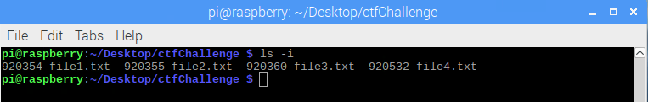

Task 3

Description
You discovered which file the attacker deleted and replaced, but you still suspect that the attacker has seen a file that he shouldn’t have, even if no changes were made. Find out which file has been viewed, but not modified. Provide screenshots for evidence.

Expected Answer:
A screenshot of the debugfs stat readout of the viewed file should be included. An accompanying paragraph should indicate that if a file is viewed using a GUI, all of the timestamps should remain the same, except for the a-time. If a file is viewed using the cat command, the c-time and the m-time should be updated, but the cr-time and a-time should be the same as the baseline. The screenshot should reflect this.

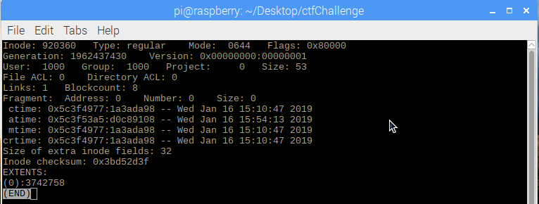
Here, only the a-time for file3.txt has changed. This indicates that the file has been viewed, but not modified.

Task 4

Description
A different file within this folder has been modified without your permission. Determine which file was modified, and when the breach occurred.

Expected Answer:
A screenshot of the debugfs stat readout of the modified file should be included. An accompanying paragraph should indicate that modified files should have a different c-time, m-time, and a-time. The new timestamp reflects the time at which the attack occurred. The fact that the cr-time has not changed indicates that it is, in fact, the original file.

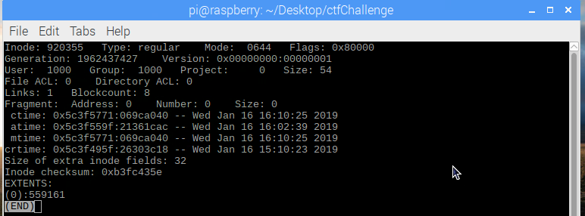
Here, the c-time and m-times are both modified, reflecting the time that the modifications were made. The a-time reflects when the file was opened, so the attacker would have had the file open from the time the a-time was updated to when the c-time and m-times were updated.

